Project name :- CUSTOMER CHURN ANALYSIS AND RETENTION STRATEGY
Tool Focus: Tableau (Visualization)
Business Goal: Reduce customer churn and improve retention
Business Problem
A telecom company is experiencing a high number of customers leaving its services. The management wants to understand the reasons behind customer churn and identify strategies to improve customer retention and satisfaction.
Business Objectives
- Identify the factors causing customer churn
- Analyze customer behavior and subscription patterns
- Measure churn rate across customer segments
- Identify high-risk customers
- Recommend retention strategies to reduce churn
Key KPIs for This Project
These will be used in Tableau dashboard.
Primary KPIs
- Total Customers
- Churned Customers
- Churn Rate (%)
- Monthly Revenue
- Average Customer Tenure
Retention KPIs
- Retention Rate
- Contract Type Distribution
- Customer Lifetime Value (CLV)
- High-Risk Customer Segment
- Revenue Lost Due to Churn

Business Insights — Customer Churn Analysis
1) Contract Type Drives Customer Churn
Customers with month-to-month contracts show significantly higher churn compared to customers with longer-term contracts such as one-year or two-year plans.
This indicates that customers without long-term commitments are more likely to switch providers or discontinue services.
Business Impact
Short-term contracts increase churn risk and reduce revenue stability.
2) Short Tenure Customers Are More Likely to Churn
Customers with low tenure (new customers) show a higher churn rate compared to long-term customers.
This suggests that the initial onboarding and early service experience strongly influence customer retention.
Business Impact
Improving the first few months of customer experience can significantly reduce churn.
3) Higher Monthly Charges Increase Churn Risk
Customers with higher monthly charges are more likely to churn compared to those with lower charges.
This indicates price sensitivity and perceived value issues.
Business Impact
Pricing strategy directly affects customer retention.
4) Payment Method Influences Churn
Customers using electronic check payment methods show higher churn rates compared to customers using automatic payment methods.
Business Impact
Manual payment methods may lead to dissatisfaction or service disruption.
5) Revenue Loss from Churn Is Significant
Churned customers contribute to lost recurring revenue, affecting overall business profitability and growth.
Business Impact
Reducing churn directly improves revenue stability.
ROOT CAUSE ANALYSIS
Root Causes of Customer Churn
Based on the analysis, the primary factors contributing to customer churn include:
- Lack of long-term contracts
- High monthly charges
- Poor onboarding experience
- Limited customer engagement
- Inconvenient payment methods
RETENTION STRATEGY
1) Promote Long-Term Contracts
Offer:
- Discounts for annual plans
- Loyalty benefits
- Contract renewal incentives
Expected Outcome
Reduced churn and improved customer retention.

2) Improve Customer Onboarding
Implement:
- Welcome programs
- Setup assistance
- Customer education
Expected Outcome
Better early customer experience and reduced early churn.
3) Introduce Pricing Optimization
Actions:
- Offer flexible pricing plans
- Provide bundled services
- Introduce promotional discounts
Expected Outcome
Improved customer satisfaction and retention.
4) Encourage Automatic Payment Methods
Actions:
- Offer discounts for auto-pay
- Simplify payment process
- Send payment reminders
Expected Outcome
Reduced payment-related churn.
5) Implement Customer Engagement Programs
Actions:
- Regular customer feedback surveys
- Loyalty rewards
- Personalized offers
Expected Outcome
Increased customer satisfaction and long-term retention.
KPI’S TO MONITOR AFTER IMPLEMENTATION
Retention Monitoring KPIs
- Churn Rate
- Customer Retention Rate
- Average Customer Tenure
- Monthly Revenue
- Customer Lifetime Value
- Customer Satisfaction Score

DOCUMENTATION
1. Project Overview
Project Title:
Customer Churn Analysis and Retention Strategy
Project Type:
Business Analysis and Data Analytics Project
Domain:
Telecommunications / Customer Retention
Tools Used:
Tableau, Microsoft Excel
Project Description:
The Customer Churn Analysis project aims to analyze customer behaviour and identify factors contributing to customer attrition in a telecom company. The project involves analyzing customer demographics, subscription details, billing information, and service usage patterns to understand churn trends.
An interactive Tableau dashboard was developed to visualize churn patterns, customer segmentation, and revenue impact. Based on the analysis, data-driven retention strategies were proposed to reduce customer churn and improve customer satisfaction.
2. Business Problem Statement
The telecom company is experiencing a high rate of customer churn, resulting in revenue loss and reduced customer loyalty. Management lacks visibility into the key factors driving customer attrition and needs actionable insights to improve customer retention.
The organization requires a structured analysis to identify churn drivers, monitor customer behavior, and implement effective retention strategies.
3. Project Objectives
The primary objectives of this project are:
- Identify factors contributing to customer churn
- Analyze customer demographics and service usage patterns
- Measure churn rate across customer segments
- Develop an interactive dashboard for monitoring churn trends
- Provide data-driven recommendations to improve customer retention
- Support business decision-making through data insights
4. Project Scope
In Scope
- Customer churn analysis
- Customer segmentation
- KPI calculation and monitoring
- Tableau dashboard development
- Identification of churn drivers
- Retention strategy recommendations
Out of Scope
- Predictive machine learning modeling
- Real-time system integration
- Customer data collection systems
- CRM implementation
5. Stakeholder Identification
Stakeholder | Role | Responsibility
Business Analyst | Project Owner | Analyze data and deliver insights
Customer Service Manager | Decision Maker | Improve customer satisfaction
Marketing Manager | Strategy Owner | Design retention campaigns
Finance Manager | Financial Analyst | Monitor revenue impact
Senior Management | Executive Stakeholder | Review performance and approve actions

6. Business Success Criteria
The project will be considered successful if:
- Customer churn patterns are clearly identified
- Key churn drivers are discovered
- Dashboard provides accurate insights
- Retention strategies are actionable
- Business decisions can be supported using data

7. Business Requirements (BRD)
Business Requirements
The following business requirements were identified to support the organization's goal of reducing customer churn and improving customer retention.
BR-01
The system shall provide visibility into the total number of customers and churned customers.
BR-02
The system shall calculate and display the customer churn rate.
BR-03
The system shall identify customer segments with high churn rates.
BR-04
The system shall analyze customer behavior based on contract type, tenure, payment method, and service usage.
BR-05
The system shall provide insights into revenue impact due to customer churn.
BR-06
The system shall enable business users to monitor customer trends through an interactive dashboard.
BR-07
The system shall support decision-making by providing actionable business insights.
8. Functional Requirements ( frd)
FR ID | Functional Requirement | Description
FR-01 | Data Import | The system shall import customer data from CSV files
FR-02 | Data Processing | The system shall clean and prepare customer data for analysis
FR-03 | KPI Calculation | The system shall calculate key performance indicators
FR-04 | Data Visualization | The system shall display charts and dashboards
FR-05 | Customer Segmentation | The system shall group customers by attributes
FR-06 | Trend Analysis | The system shall analyze churn trends over time
FR-07 | Reporting | The system shall generate reports for business users

9. Non Functional Requirements
NFR ID | Requirement | Description
NFR-01 | Performance | Dashboard should load within 5 seconds
NFR-02 | Usability | Dashboard should be easy to understand
NFR-03 | Reliability | Data calculations should be accurate
NFR-04 | Scalability | System should handle large datasets
NFR-05 | Security | Customer data should be protected
NFR-06 | Availability | Dashboard should be accessible during business hours

10. User Stories
User Story ID | User Story
US-01 | As a Business Analyst, I want to view total customers so that I can monitor customer base size
US-02 | As a Manager, I want to see churn rate so that I can measure customer retention
US-03 | As a Marketing Manager, I want to identify high-risk customers so that I can create retention campaigns
US-04 | As a Finance Manager, I want to monitor revenue impact so that I can evaluate financial performance
US-05 | As a Customer Service Manager, I want to analyze customer complaints so that I can improve service quality
US-06 | As a Decision Maker, I want to view dashboard insights so that I can make informed business decisions

11.Acceptance Criteria
Acceptance Criteria
The system will be accepted if:
- Customer data is successfully imported
- KPIs are calculated accurately
- Dashboard displays correct visualizations
- Churn trends are clearly visible
- Reports support business decision-making

12. Process Flow Diagram — Customer Churn Analysis System
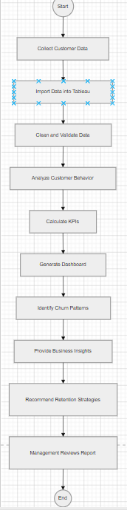
The process flow diagram represents the sequence of activities involved in analyzing customer churn data. The process begins with collecting customer data and importing it into the analytics system. The data is cleaned and validated before performing analysis and calculating key performance indicators. The system then generates dashboards to identify churn trends and provide business insights. Based on these insights, retention strategies are recommended to support business decision-making.

13. Activity Diagram – Customer churn Analysis
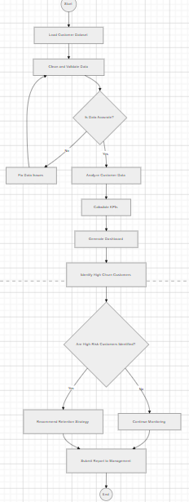
The activity diagram illustrates the workflow involved in analyzing customer churn data and identifying high-risk customers. The process begins with loading and validating customer data. If the data is not accurate, data issues are resolved before proceeding with analysis. The system calculates key performance indicators and generates dashboards to identify churn patterns. Based on the analysis, retention strategies are recommended and reported to management for decision-making.

14. Use Case Diagram — Customer Churn Analysis System
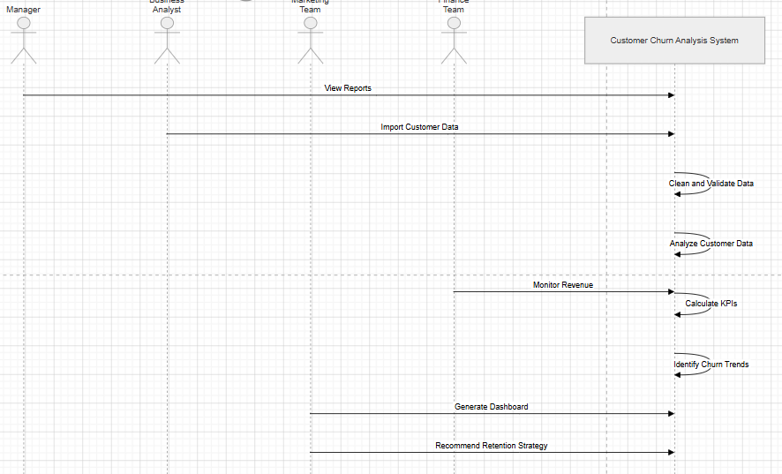
Actor Roles
Business Analyst
- Imports and prepares data
- Performs churn analysis
- Generates dashboards
Manager
- Reviews churn reports
- Makes business decisions
Marketing Team
- Designs retention campaigns
- Targets high-risk customers
Finance Team
- Monitors revenue impact
- Evaluates financial performance
15.User Acceptance Testing (UAT)
UAT Scope
The following components were tested:
- Customer data import
- KPI calculations
- Dashboard visualizations
- Churn analysis functionality
- Reporting accuracy
- System usability

UAT Test Scenarios and Results
Test Case ID | Test Scenario | Expected Result | Actual Result | Status
UAT-01 | Import customer dataset | Data loads successfully into system | Data loaded successfully | Pass
UAT-02 | Calculate total customers | Correct total customer count displayed | Correct count displayed | Pass
UAT-03 | Calculate churn rate | Accurate churn rate calculation | Accurate churn rate displayed | Pass
UAT-04 | Generate dashboard | Dashboard displays visualizations correctly | Dashboard displayed correctly | Pass
UAT-05 | Identify high churn segments | High-risk customer segments identified | Segments identified successfully | Pass
UAT-06 | View reports | Reports accessible to stakeholders | Reports accessible | Pass
UAT-07 | Monitor revenue impact | Revenue metrics calculated correctly | Revenue metrics accurate | Pass

UAT Acceptance Criteria
The system is considered acceptable if:
- Customer data is imported without errors
- KPIs are calculated accurately
- Dashboard visualizations are displayed correctly
- Churn trends are clearly identified
- Reports support business decision-making
- Stakeholders can use the dashboard without difficulty
UAT Approval Table

Stakeholder | Role | Approval Status
Business Analyst | Project Owner | Approved
Marketing Manager | Business User | Approved
Customer Service Manager | Stakeholder | Approved
Finance Manager | Financial Reviewer | Approved

UAT Conclusion
User Acceptance Testing confirmed that the Customer Churn Analysis system meets business requirements and provides accurate insights for monitoring customer behaviour and reducing churn. The dashboard and reporting features were validated by stakeholders and approved for business use.

16.PROJECT SUMMARY
Project Summary
The Customer Churn Analysis project was conducted to identify the key factors contributing to customer attrition and to develop data-driven strategies to improve customer retention. The project involved analyzing customer demographic information, subscription details, billing data, and service usage patterns to understand customer behaviour and churn trends.
A structured business analysis approach was followed, including requirement gathering, data analysis, dashboard development, and solution evaluation. Customer data was cleaned, validated, and analyzed using Microsoft Excel and Tableau to calculate key performance indicators such as churn rate, customer count, and revenue metrics.
An interactive Tableau dashboard was developed to visualize customer churn patterns based on contract type, tenure, payment method, and monthly charges. The dashboard enabled stakeholders to monitor customer behavior and identify high-risk customer segments.
Based on the analysis, several retention strategies were proposed, including promoting long-term contracts, improving customer onboarding, optimizing pricing plans, and encouraging automatic payment methods. These strategies aim to reduce customer churn, improve customer satisfaction, and support business growth.
The project demonstrated the role of a Business Analyst in transforming raw customer data into actionable business insights and supporting data-driven decision-making.

#Key Business Insights
You can keep this as a separate section in your document.
Insights Identified from Analysis
- Customers with month-to-month contracts showed the highest churn rate
- Customers with shorter tenure were more likely to churn
- Higher monthly charges were associated with increased churn risk
- Certain payment methods showed higher churn behaviour
- Customer churn resulted in revenue loss and reduced customer retention
#Business Recommendations
Recommended Retention Strategies
- Offer discounts and incentives for long-term contracts
- Improve customer onboarding and early engagement
- Introduce flexible pricing plans and bundled services
- Encourage automatic payment methods
- Implement customer loyalty and engagement programs

Business Impact
The project provided valuable insights into customer behaviour and churn patterns, enabling stakeholders to make informed business decisions. The dashboard improved visibility into customer retention metrics and supported the development of targeted retention strategies.
The analysis demonstrated how data-driven decision-making can reduce customer churn, improve customer satisfaction, and increase revenue stability.
Tools and Technologies Used
- Tableau
- Microsoft Excel
- Data Visualization
- Business Analysis
- KPI Monitoring
- Customer Segmentation
- Data Cleaning and Validation
